Fitment of Nippy Normans dual USB socket to F750GS/850GS
Slightly tricky on these models but follow the below and straight forward and looks like an original fitment.
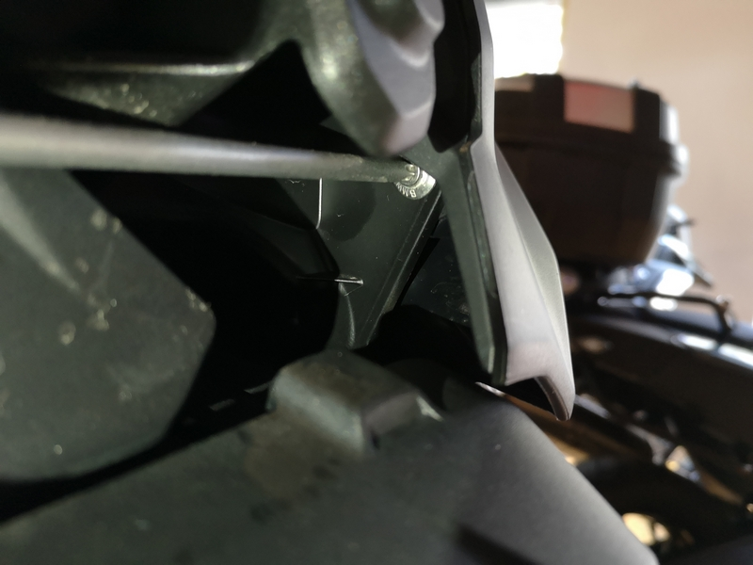
Need to remove the black plastic cover where the original DIN socket is sited:
- One clip (not screw) below dash display.
- One screw visible in rear end of the cover.
- Another screw in front not so easily visible maybe better to remove windscreen.
- Black plastic cover comes off and exposes the back part of DIN socket.
- Remove connector.
- The little spanner supplied he is not useful as the nut is positioned in a recessed plastic feature. Use tubular 22mm tool or pliers to remove the nut.
- Connect and fit the new dual USB socket.
- Reassemble all back
